When to Buy Home and Kitchen Appliances
So, you are out window shopping and you suddenly come across a beautiful sweater on display? It is just the color that you need and just your size. Wait, there’s more... It’s on sale, but it’s the summer season. So what? You will wear it in winter. So you rush into the store and grab that sweater. There are certain things like clothes, shoes, and that sweater that you can buy even if you don’t need them immediately. Other things, however, are costly and important investments; you can’t buy them “out of season” and without careful consideration. Kitchen and home appliances are among these things.
Blenders, juice-makers, coffee-makers, freezers, refrigerators, washing machines, television, water dispenser, etc. are just a few examples of home and kitchen appliances. These embedded systems have become a big part of our lives. Some of these appliances are must-haves; you can’t live without them (But not all of them!). It is important to understand that these electronic devices have different costs and models. You need to consider several factors before buying a home appliance. These factors include:

- What you need
You can’t just go out and grab a brand new toaster when you already have a perfectly good one at home. If your blender is broken, then buy a blender. If you don’t find one then wait for a few days and go out looking for one again; the objective is to know what you need and when you need it.
- What you can afford
This is an important factor. You will find appliances in a wide range of prices. You can search online and look for appliances that fall in your range. A better option is to ask for help from the salesperson at the store. Give him your budget and he will tell you which models suit your needs.
- Energy consumption.
Refrigerators, washing machines and dishwashers are examples of some home appliances that use a lot of energy, thereby adding to your utility bill. It is better to look for energy efficient appliances. These will be more expensive than the regular appliances, but they are worth it because they will be a one-time investment and you will notice a considerable reduction in your electricity bill.
That being said, let us now consider the circumstances under which you can buy home or kitchen appliances. Recall that home appliances are important investments because they can last a lifetime and are costly. So following are a few situations in which you can consider spending money on buying kitchen or home appliances:
- You are moving into a new residence and you want to start afresh with new furniture, appliances, drapes, etc. So you can sell your older appliances and buy new ones.
- You are getting married! Obviously a bride needs a lot of new things for her new home and that includes appliances like refrigerator, freezer, toaster, television etc.
- You are bored of the old look and are looking to remodel your kitchen. Say you had a traditional old fridge, but now you will have a wall refrigerator with built-in water dispenser. For that purpose you need to buy a fridge that comes with a dispenser and get rid of your old dispenser.
- Some of your old appliances are, well, too old now. You will need new ones that are more efficient and that actually work properly.
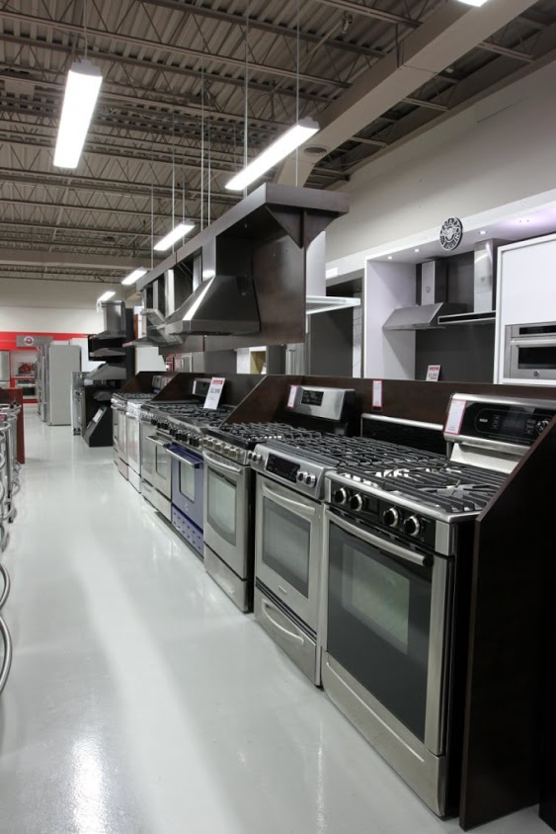
Remember that regardless of the reason for which you are out shopping for appliances, you must carefully consider all the factors before selecting one; especially if you are doing this for the first time. A better option will be to take along a family member or a friend who has some experience in the area; it is never harmful to have second opinions! They will share their experiences and recommend the model and make of the particular appliance that you need.
If you don’t want to bother your friends, then you can sit online, do a little homework and decide that which appliance will be best to cater your needs before you go out to the store. If you are adequately satisfied, then you can even order an appliance from an e-store. That will save you a lot of hassle!
Jake Smith is a Content Editor at Canadian Appliance Source Mississauga. He also writes on technology and electronics as the main subject and many more topics for the past five years.

